DISSERTATION FORMATTING GUIDE
FOR PHD STUDENTS

Need help? Contact:
grad-degree@provost.upenn.edu

Updated 1/18/2023

Table of Contents
OVERVIEW 1
FORMATTING FOR THE ENTIRE DOCUMENT 2
File Type 2
Organization of pages 2
Margins 3
Fonts 5
Headings and Subheadings 5
Spacing 5
Text Alignment 6
Pagination 6
Landscape Pages 7
TITLE PAGE 7
COPYRIGHT NOTICE 8
Creative Commons Note 9
DEDICATION 9
ACKNOWLEDGMENT 9
ABSTRACT 10
TABLE OF CONTENTS 12
LIST OF TABLES 15
LIST OF ILLUSTRATIONS OR LIST OF FIGURES 17
OTHER LISTS 18
PREFACE 18
MAIN TEXT OF THE DISSERTATION 19
An example of a subheading 19
USING PREVIOUSLY PUBLISHED ARTICLES 19
FOOTNOTES OR ENDNOTES 21
APPENDICES 21
BIBLIOGRAPHY 22
APPENDIX A: OFFICIAL NAMES OF GRADUATE GROUPS 23
APPENDIX B: USING HEADING STYLES 25

OVERVIEW

At the University of Pennsylvania, a PhD candidate presents and defends the dissertation publicly, and then, with the approval of the dissertation committee and graduate group chair, submits the final manuscript for publication to the Office of the Provost. The PhD degree is awarded to the candidate upon the recommendation of the Graduate Council of the Faculties.
In preparation for the submission of a dissertation for publication, degree candidates should consult these guidelines early and often for assistance with the formatting of their manuscript. Other resources include Formatting Templates (Word and LaTeX versions are available), a Formatting Checklist, and Formatting FAQs. Formatting will likely take longer than anticipated, so please set yourself up for success by following the formatting guidelines for your own document early in the process or using the dissertation templates provided.
Complete the PhD Dissertation Formatting Checklist to ensure you have followed all formatting requirements. Dissertations that do not comply with these guidelines will not be accepted and will require revisions before being approved.

FORMATTING FOR THE ENTIRE DOCUMENT

File Type
Final dissertations must be uploaded to ETD Administrator in PDF format. After converting to PDF, please review the entire document to make sure that all sections and formatting converted properly, especially images and graphs which may have been affected by the conversion.

Organization of pages
Pages must appear in the following order
- Preliminary Pages: This is the front matter of your dissertation. The Title Page and Copyright Notice do not have page numbers. All other pages in this section use lowercase Roman numerals for page numbers (ii, iii, iv). Do not add sections that are not listed below; additional sections may be included as Appendices.
- Title Page (required; no page number but is counted as page i)
- Copyright Notice (optional; no page number, but counted as page ii, if included)
- Dedication (optional)
- Acknowledgment (optional)
- Abstract (required)
- Table of Contents (required)
- List of Tables (required if the main text includes tables)
- List of Illustrations (required if the main text includes illustrations, figures, photos, maps, schemes, or pictures)
- Preface (optional)
- Main Text: (required) This is the body of your work beginning on page 1. This section uses Arabic numerals for page numbers (1, 2, 3).
  - Chapters must have a title and a number (example: CHAPTER 1: TITLE OF CHAPTER) and must be listed in the Table of Contents.
  - The main text section may include Footnotes or Endnotes.
- Appendices (optional)
- Bibliography (required)
- Index: An index is optional for most graduate groups, but it is required for the following graduate groups:
- Architecture
- City & Regional Planning
- Earth & Environmental Science
- East Asian Languages & Civilization
- Near Eastern Languages & Civilization

Margins
IMPORTANT: Absolutely nothing may be in the blank margin space. Page numbers, footnotes, headers, and any part of any tables, figures, schemes, and text must all be kept out of the margin space.
Margins on every page of the dissertation must be 1 inch on each side (updated December 2022).
- left margin: 1 inch
- right margin: 1 inch
- top margin: 1 inch
- bottom margin: 1 inch
Do not use a running head (printing the page title on every single page) in your dissertation.
Microsoft Word Tip: You may view your margins in Word by using the rulers at the top and side of the document. You may also enable Show text boundaries to see if any of your text, images, or frames land outside of the margins by following these steps:
- Click on the File menu
- At the bottom of the left-hand menu, click Options
- On the left-hand menu, click on the Advanced tab
- Under the heading Show document content, select Show text boundaries
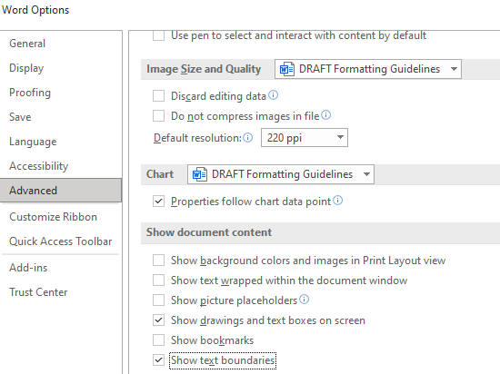
Illustration 1: Show text boundaries
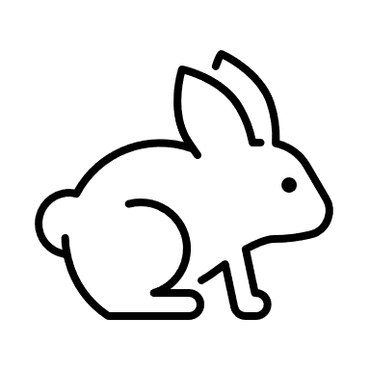
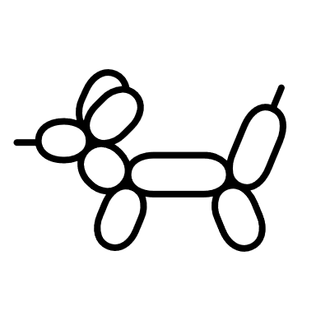
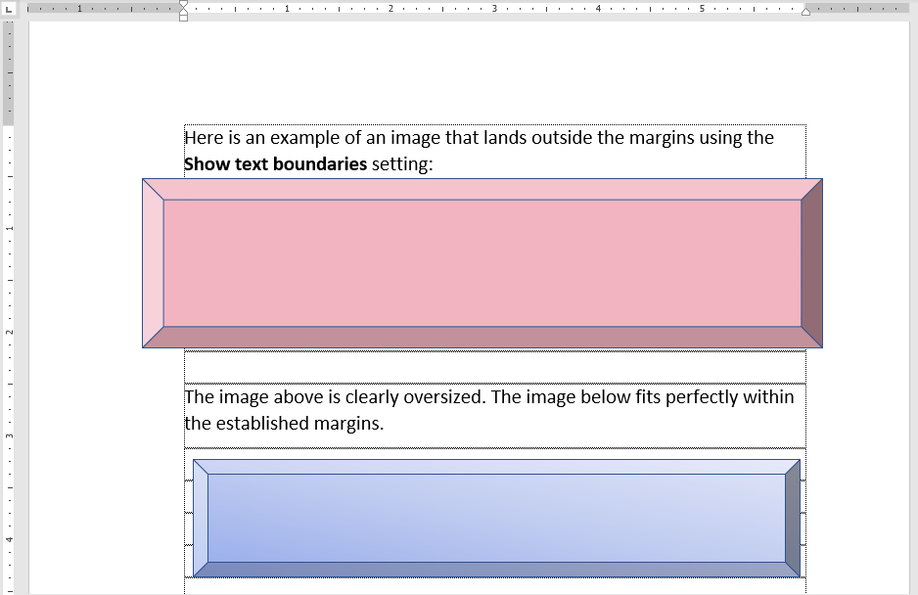
Illustration 2: Examples of images inside and outside the text boundaries

Fonts

A font 10-12 points in size and a consistent color (black) should be used. We recommend Arial (10pt), Calibri (11pt), Georgia (11pt), or Times New Roman (12 pt).
For footnotes, figures, citations, charts and graphs, a font of 8 points or larger should be used. Italic type may be used for quotations, words in a foreign language, occasional emphasis, book titles, or to differentiate subheadings.
When converting your document to PDF, the fonts must be embedded. ProQuest ETD Administrator has a how-to guide for embedding fonts using Microsoft Word on a PC or Mac.

Headings and Subheadings
Preliminary pages and chapters must include headings in ALL CAPITAL LETTERS (example: CHAPTER 1: TITLE). Headings may be larger than the main text but should not exceed 36 point font nor should there be excessive spacing. Headings should be a consistent font color (black) to match the rest of the text. You may choose to include subheadings for sections within a chapter; subheadings may be italicized or bolded and are not required to be in all capital letters.
Microsoft Word Tip: By using the Styles menu in Word, you can designate different levels of headings to correspond to the chapter headings and subheadings in your dissertation. If you designate chapter headings as “Heading 1” and chapter subheadings as “Heading 2,” then your table of contents can be accurately and quickly generated using the References tab. See Appendix B.

Spacing
We recommend double-spacing the text of your dissertation, including the preliminary pages and the Bibliography. Only the following parts of your text are required to be single-spaced:
- Footnotes
- Long quoted passages (more than four lines of prose or three lines of verse)

Text Alignment
Your main text must be either left-aligned or justified.
You may choose to indent new paragraphs or sections, but it is not required.

Pagination

- The Title page DOES NOT have a page number, but for counting purposes, it is considered page i.
- The optional Copyright notice DOES NOT have a page number, but for counting purposes, it is considered page ii.
- The preliminary pages are numbered with lowercase Roman numerals (ii, iii, iv…) from the optional Dedication page through the end of the optional Preface.
- The main text is numbered with Arabic numerals (1, 2, 3) from the first page of Chapter 1 to the end of the Bibliography or optional Index.
- In Word, the best way to manage the transition from using roman numeral page numbers for the preliminary pages and Arabic numerals for the main text is to use a section break. For more information on section breaks, visit Microsoft Office Support.
- Page numbers cannot appear in the blank margin space.
- Page numbers are recommended to be at the bottom of your page, but you may also choose to put them at the top. Whether they are at the bottom or the top of the page, there must still be 1 inch of blank margin space between the page number and the edge of the page.
Microsoft Word Tip: In Word, this can be adjusted when you click the page number in the footer. The Header & Footer menu will show at the top; in the Position section, increase the Header from Top or Footer from Bottom distance to 1 inch.
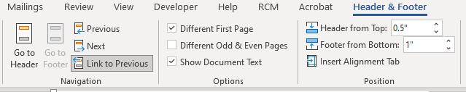
Illustration 3: Adjusting Footer from Bottom to 1 inch

Landscape Pages

Landscape oriented images and tables are allowed, but they must be formatted as they would be in a book: i.e., they are rotated counterclockwise 90 degrees and bound along the top. Landscape pages must also have 1 inch margins on all sides. The page number will be on the left side of the page (instead of the bottom), and the number will be horizontal.
The easiest way to format your landscape page is to rotate your image and its caption so that the page remains in portrait orientation, but the top of the image is to the left and the bottom of the image is to the right.
View a sample of a properly formatted landscape page.

TITLE PAGE

The title page is required. View a sample title page here.
- The title page is understood to be page “i” for counting purposes, but no page number should be printed on the title page.
- The title of your dissertation must be centered one inch from the top of the page in all UPPERCASE letters. If the title is more than one line, it must be double-spaced.
- Your name on your title page must match your name on your student record in Path@Penn. If you want to use a name that differs from the name in Path@Penn, please provide the necessary documentation with the Student Data Change Form to the Office of the University Registrar.
- The official graduate group name is very specific and must match the name as listed in the Official Names of Graduate Groups.
- Students in Romance Languages or Managerial Science and Applied Economics (Wharton) must also include their field of specialization above the graduate group name. These students should view the sample Romance Languages and Wharton Title Pages.
- The year must be the current year of your deposit.
- Signatures on the title page are optional. Unsigned title pages are accepted. If a candidate chooses to include signatures, the dissertation supervisor(s) and the graduate group chair must all sign.
- All committee member names must be included on the title page. Do not omit any committee members.
- The full faculty title will include the professor’s rank and department, if they hold a named professorship, and, for any external committee members, their affiliation. You do not need to list any Penn schools (for example: Perelman School of Medicine) on the title page.
- All faculty names on the title page must be formatted consistently. For example, if you include PhD or MD for one faculty member, include them for all.

COPYRIGHT NOTICE

The copyright page is optional. The United States does not require you to include a copyright notice or formally register to have copyright protections over your work. See the Dissertation Copyright guidelines for more information and to schedule a copyright consultation.
- If you do include a copyright page:
  - Do not put a page number on the copyright page. It is understood to be page “ii.”
  - The page numbers should start appearing on the page after the copyright page and will start with “iii”.
- If you do not include a copyright page, numbering starts on the page after the title page, page ii.
The copyright page consists of 4-5 lines:
- The first line of the copyright page is the full title of your dissertation in ALL UPPERCASE letters.
- The second line is the word COPYRIGHT in all capital letters. Do not include the symbol ©.
- The third line is the current year.
- The fourth line should be your full, legal name with full middle name, and in normal capitalization (e.g., Jane Jean Doe).
- You may optionally include a Creative Commons note (see below).
Creative Commons Note
You may choose to use a Creative Commons License, which allows you to tell others certain ways in which they may reuse your work without first asking permission from you (note that you still retain copyright, some rights reserved). This is optional. If using, go to https://creativecommons.org/choose to choose a license and add the appropriate information in the template.

DEDICATION

The dedication page is optional.
- It uses a small Roman numeral page number (ii, iii…).
- The dedication page does not use a heading
- The dedication page does not appear in the Table of Contents.
- The dedication text must be in italics.

ACKNOWLEDGMENT

The acknowledgment page is optional.
- It uses a small Roman numeral page number (ii, iii, iv…).
- The acknowledgment page header (“ACKNOWLEDGMENT” or “ACKNOWLEDGMENTS” must be in ALL UPPERCASE LETTERS.
- The acknowledgment page must be listed in the Table of Contents.

ABSTRACT

The abstract page is required. The abstract will be published online by ProQuest in Dissertation Abstracts International and on ScholarlyCommons (Penn’s institutional repository), providing information to interested readers about the general content of the dissertation. Please pay close attention to the required content, as this page is a common source of errors.
- This page uses a small Roman numeral page number (ii, iii, iv…).
- The abstract is a condensed summary of the dissertation, not to exceed 350 words.
- All words, including the title and names, count toward the 350-word total.
- The abstract page is double-spaced.
- The abstract page must be listed in the Table of Contents.
- The abstract, which is normally a single paragraph, consists of four parts: the statement of the problem; the procedure and methods used to investigate the problem; the results of the investigation; and the conclusions.
- The dissertation title must match the title on your optional copyright notice and required title page.
- The dissertation author’s name must match the name on your student record and title page.

At the top of the page will be these 4-5 lines of text:
- The first line is the word "ABSTRACT" in ALL UPPERCASE letters.
- The next line is the TITLE of the dissertation in ALL UPPERCASE letters.
- The next line is the author’s (your) name in normal capitalization (e.g., Jane J. Doe). It must match your name as it appears in Path@Penn.
- The next line is your dissertation supervisor's name with normal capitalization. Do not include any titles as this is indicated by the placement of the names (for example, do not include Professor, Co-Supervisor, Dr., or Ph.D.).
- Only if you have a co-supervisor: on the next line after the supervisor’s name is the co-supervisor’s name with normal capitalization and no titles (for example, do not include Professor, Co-Supervisor, Dr., or Ph.D.).
Example:

ABSTRACT
DISSERTATION TITLE IN ALL UPPERCASE LETTERS
Caroline Gonzalez Ciccone
Benjamin Franklin
Thomas Jefferson

The abstract text uses my remaining 337 words, since there are 13 words in the names and title. Here I would have a condensed summary of all my research, including the statement of the problem; the procedure and methods used to investigate the problem; the results of the investigation; and the conclusions.

TABLE OF CONTENTS

- It uses small roman numeral page numbers (iii, iv…).
- The table of contents page is required.
- The heading must be “TABLE OF CONTENTS” in ALL UPPERCASE LETTERS.

The table of contents must include the following:
      - Acknowledgment (if included in your dissertation)
      - Abstract (required)
      - List of Tables (required if the main text includes tables)
      - List of Illustrations or List of Figures (required if the main text includes illustrations, figures, photos, maps, schemes, or pictures)
      - Preface (optional)
- All Chapters (example: CHAPTER 1: TITLE OF CHAPTER, etc.)
  - Subsections – if your text contains subsections, it is recommended to include them in the Table of Contents. They should be included in a consistent format.
- Appendices (if included in your dissertation)
  - Each Appendix must be listed. For example:
APPENDIX A: TITLE OF APPENDIX
APPENDIX B: TITLE OF APPENDIX
- Bibliography
Microsoft Word Tip: Word allows you to automatically generate a table of contents. By using the Styles menu in Word, you can designate different levels of headings to correspond to the chapter headings and subheadings in your dissertation. If you designate chapter headings as “Heading 1” and chapter subheadings as “Heading 2,” then your table of contents can be accurately and quickly generated using the References tab.
You may choose to have your Table of Contents be hyperlinked to sections within your document, but if you include hyperlinks, they must be consistent (included for all sections and in a consistent format).
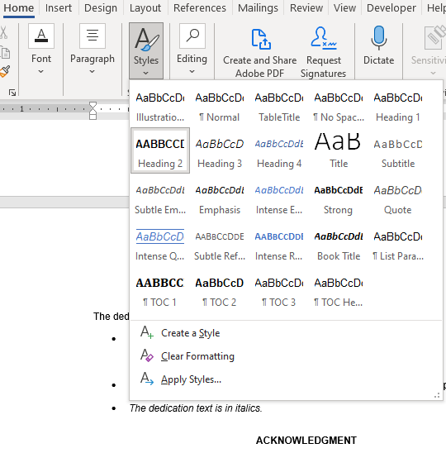
Illustration 4: Selecting Heading 2 in the Styles menu
To generate a Table of Contents:
- Open the References tab from the top menu in Word
- Select the Table of Contents drop-down menu
- Select a table of contents style
- Whenever you add chapters or subchapters, you can click on your Table of Contents and select Update Field and Update Entire Table which will automatically update the listings and page numbers.
- For more information on how to automatically generate a table of contents in Word, please see: https://support.microsoft.com/en-us/office/insert-a-table-of-contents-882e8564-0edb-435e-84b5-1d8552ccf0c0.
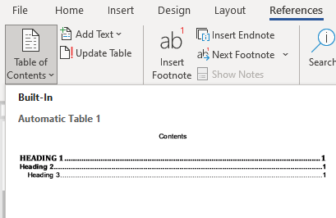
Illustration 5: Adding a Table of Contents from the References tab
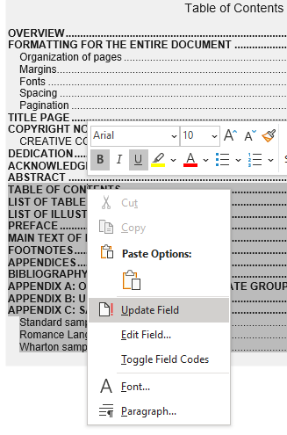
Illustration 6: Right click and select Update Field to automatically update the Table of Contents

LIST OF TABLES

The List of Tables is required if your document has tables in the text.
- This page has a small roman numeral page number because it is a preliminary page (ii, iii, iv)
- It should be titled LIST OF TABLES in ALL UPPERCASE LETTERS.
- The List of Tables is meant to help readers navigate to the location of each table in the manuscript; thus, it is formatted like a table of contents with page numbers for each table.
- Make sure all tables are labeled with a number and title. Numbering must be consecutive and match your chosen citation style (e.g., MLA, APA, Chicago).
- The list itself may be single or double-spaced.
- The List of Tables must be included in the Table of Contents.
- Tables in the appendices do not need to be included in the List of Tables.
Microsoft Word Tip: This list can also be automatically generated in Microsoft Word, if you use the References menu to format your table captions. For more information on how to do this, please see this short tutorial: https://www.youtube.com/watch?v=z6NP31Q1w3M.
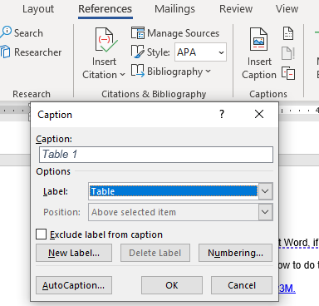
Illustration 7: Inserting a Table caption using the References tab

Once you have captions, you can insert your list using the References tab to select Insert Table of Figures.
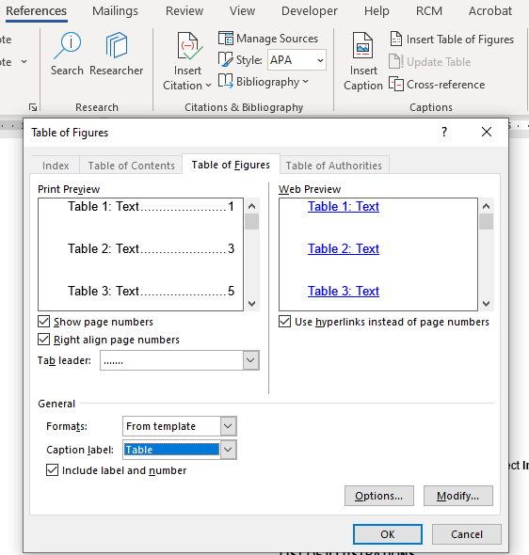
Illustration 8: Using the Table of Figures function in the References tab to make a List of Tables

LIST OF ILLUSTRATIONS OR LIST OF FIGURES

The List of Illustrations or List of Figures is required if your document has illustrations, photos, pictures, figures, maps, or schemes in the text. It goes after the List of Tables if you have one, or after the Table of Contents if there is no list of Tables.
- This page uses a small roman numeral page number (iv, v, vi…) because it is a preliminary page.
- It must be titled LIST OF ILLUSTRATIONS or LIST OF FIGURES in ALL UPPERCASE LETTERS.
- The List of Illustrations or List of Figures is meant to help readers navigate to the location of each illustration or figure in the manuscript; thus, it is formatted like a table of contents with page numbers for each illustration or figure.
- Make sure all illustrations and figures are labeled with a number and title. Numbering must be consecutive and match your chosen citation style (e.g., MLA, APA, Chicago).
- The list itself may be double-spaced or single-spaced (suggested for long lists).
- The List of Illustrations or List of Figures must be included in the Table of Contents.
- Illustrations/figures in the appendices do not need to be included in the List of Illustrations or List of Figures.
Microsoft Word Tip: This list can also be automatically generated in Microsoft Word if you use the References menu to format your illustration captions. For more information on how to do this, please see the section on List of Tables above or this tutorial: https://www.youtube.com/watch?v=z6NP31Q1w3M

OTHER LISTS
If required by your field, you may choose to include an optional List of Abbreviations or List of Translated Words. These lists should be included in the Appendix and should be identified with an appropriate heading and formatted similar to the other lists.

PREFACE

Including a Preface is optional.
- If you choose to include a Preface, it uses small roman numeral page numbers as it part of the preliminary pages.
- It must be called “PREFACE” in ALL UPPERCASE letters.
- The Preface must be included in the Table of Contents.
- Introductions are not part of the preliminary pages and are considered part of the main text, so should start at page 1.

MAIN TEXT OF THE DISSERTATION

- The main body of your dissertation begins with page 1, which will either be an Introduction or Chapter 1.
- From this point on, your pages will have Arabic numerals (1, 2, 3…).
- All chapters must be numbered.
- You must include the chapter number and chapter title on the first page of each chapter in ALL UPPERCASE LETTERS.
- Chapters titles and headings should be formatted in a consistent heading style so that they appear on your Table of Contents.
- The font and size of the text should be uniform all the way through.
CHAPTER 2
AN EXAMPLE OF A CHAPTER TITLE

An example of a subheading
An example of normal text in the chapter.

USING PREVIOUSLY PUBLISHED ARTICLES
University of Pennsylvania policy allows you to include your own previously published work or articles submitted for publication as part of the dissertation with the following conditions:
- You must obtain approval of the dissertation committee and Graduate Group Chairperson.
- You must obtain written permission from the copyright owner, which may be the journal, publisher, and/or any co-authors, unless you are the sole copyright holder (depends on your publishing agreement).
- You must upload any permission letters in ETD Administrator as a supplemental file titled “Permission Letter – Do Not Publish.”
- For dissertations based on joint work with other researchers, a unique and separate dissertation must be presented by each degree candidate. You must include a concise account of your unique contribution to the joint work, and remainder of the dissertation must be authored solely by you. Authorship of an entire dissertation by more than one degree candidate is not allowed.
- Your dissertation must be formatted as a single document with consistent formatting and styles throughout. If you are using multiple previously published articles, make sure to make the formatting consistent with the rest of the document.
When using previously published or in press work, you must disclose this information in your dissertation in the following format:
- Under the Chapter title, list the full citation for the previously published/in-press article in the citation style used in your Bibliography.
- If it is a jointly authored article, describe your contribution to the work in a separate sentence.
EXAMPLE:
CHAPTER 3
TITLE OF CHAPTER
This chapter was previously published/is in press as [insert full citation in your citation format: Author Name(s). Title of Article. Journal. Year. Link if any]. For jointly authored articles, include a description of your contribution to the work.
Start of Chapter text.

FOOTNOTES OR ENDNOTES

Notes can appear as footnotes below the text on a page, or as endnotes at the end of each chapter. You must choose to use either footnotes or endnotes throughout your dissertation. You cannot vary between footnotes and endnotes in different chapters.
- Footnotes and endnotes must be single-spaced.
- Footnotes at the bottom of a page must be numbered continuously throughout the dissertation. The count must not restart with each chapter. For example, if Chapter 1 has 20 footnotes then the footnotes for Chapter 2 should start at 21.
- A bottom-of-the-page footnote must begin on the same page as the text to which it refers, but it may continue on the following page if necessary.
- Footnotes may never go in the blank margin space.
- Endnotes at the end of a chapter are numbered separately for each chapter (i.e., the first note of each chapter will always be numbered “1”).

APPENDICES
Appendices are optional.
- All Appendices must be labeled with a capital letter. Example:
APPENDIX A: TITLE OF APPENDIX A
APPENDIX B: TITLE OF APPENDIX B
- If you have Appendices for each chapter, they must still go at the end of the main text. You can indicate that they refer to a particular chapter in the Appendix title; for example:
APPENDIX A: SUPPLEMENTAL MATERIAL FOR CHAPTER 4
APPENDIX B: SUPPLEMENTAL MATERIAL FOR CHAPTER 5
- You must list all Appendices in the Table of Contents.
- Tables and Figures in the appendices must be labeled, but do not need to be included in the List of Tables or List of Illustrations.

BIBLIOGRAPHY

The Bibliography is required.
- The Bibliography is an alphabetical listing of all references or a numbered reference list, depending on the citation style for your field.
- If your list is numbered, the entries must be in order of use.
- Page numbers in the bibliography continue the pagination of the main text; do not number the bibliography separately.
- The Bibliography should be double spaced, but you may choose to single space the text.
- You may include end-of-chapter bibliographies instead of an end-of-work bibliography if that is the standard formatting for your field.

APPENDIX A: OFFICIAL NAMES OF GRADUATE GROUPS
The title page must show the formal version of the graduate group name. Do not add the words “Graduate Group in” or “Department of.” Only use the name as pictured below. This list was last updated on November 22, 2022. A list of Graduate Group names is also available at https://provost.upenn.edu/phd-graduate-groups.
Africana Studies
Ancient History
Anthropology
Applied Mathematics and Computational Science
Architecture
Art and Archaeology of the Mediterranean World
Biochemistry and Molecular Biophysics
Bioengineering
Biology
Cell and Molecular Biology
Chemical and Biomolecular Engineering
Chemistry
City and Regional Planning
Classical Studies
Communication
Comparative Literature and Literary Theory
Computer and Information Science
Criminology
Demography
Earth and Environmental Science
East Asian Languages and Civilizations
Economics
Education
Electrical and Systems Engineering
English
Epidemiology and Biostatistics
Genomics and Computational Biology
Germanic Languages and Literatures
History of Art
History
History and Sociology of Science
Immunology
Linguistics
Managerial Science and Applied Economics
Accounting
Applied Economics
Ethics and Legal Studies
Finance
Health Care Management & Economics
Management
Marketing
Operations, Information and Decisions
Statistics and Data Science
Materials Science and Engineering
Mathematics
Mechanical Engineering and Applied Mechanics
Music
Near Eastern Languages and Civilizations
Neuroscience
Nursing
Pharmacology
Philosophy
Physics and Astronomy
Political Science
Psychology
Religious Studies
Russian and Eastern European Studies
Romance Languages
French and Francophone Studies
Hispanic Studies
Italian Studies
Sociology
Social Welfare
South Asia Regional Studies

APPENDIX B: USING HEADING STYLES

This guide uses- and we recommend that you use- an automatically generated Table of Contents. By formatting chapters and chapter titles as “Heading 1” and subheadings as “Heading 2” under the Styles menu located in the Home tab in Word, your table of contents can be accurately and quickly generated and updated.
To format a chapter title, just select the text and click the Heading 1 button on the Home menu seen in the illustration below.
To change the font size and color of a Heading Style, format the chapter title as you want it to appear, then highlight the chapter title. In the Styles menu, right click Heading 1 and select Update Heading 1 to Match Selection. This will automatically format all text that is marked as Heading 1. You can use the same process to format subheadings using Heading 2.
Illustration 3.
Screenshot Of Styles Menu on Home Screen with Heading 1 Selected
